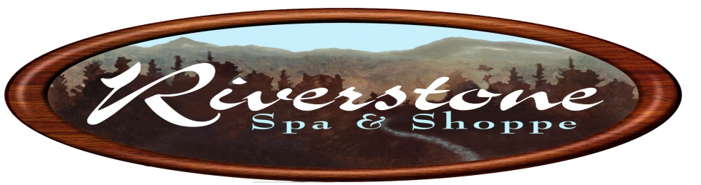
Imperial Square Shopping Center
975 Imperial Golf Course Blvd #114, Naples, FL 34110
Riverstonespanaples.com
(239) 254-9984

Preparing for your session
We recommend 3-4 days prior to your session to do the following to get the best results.
- Drink plenty of water!
- Avoid gas-causing foods such as legumes, hummus, broccoli, raw kale, all nuts, cauliflower, corn and cabbage.
- Avoid processed and rich foods. Such as breads, sweets, dairy products (i.e. ice cream and cheese)
- Avoid all protein powders, shakes and bars. Even plant-based protein. They can be severely constipating. We do not recommend them, ever.
- Please avoid protein shakes 2 days prior to your appointment.
- If you are doing your colon hydrotherapy session as part of a more in-depth cleanse, now is the time to begin it.
- Print and fill out the new client intake form attached to this email. If you do not have access to a printer please arrive 10-15 minutes early for your session so that you have time to complete all paper work.
In the 2 hours prior to your session…
- It is best not to eat unless you have a medical condition that prevents you from fasting before your treatment.
The hour before your session…
- Do not drink any liquids.
It is important to stop eating and drinking prior to your session because the session will include abdominal massage, which is more comfortable on an empty stomach and bladder.
*When you arrive for you session please look for Running With Scissors (next door) to locate our office. We do not have a sign on the concrete part of the building, so when you see Running With Scissors go ahead and park.

Natural Remedies, Alternative Medicine Disclaimer
The material contained in this website, including information on natural remedies, homeopathy, and alternative medicine, is for informational purposes only. No assumptions should be made regarding its accuracy. Any information provided here, and any recommendations made should not be used to, nor are intended to, diagnose, treat, cure or mitigate any specific health problem. Anybody with any health complaints should seek the care and consultation of an appropriately licensed health care practitioner. No attempt should be made to use any information provided here as a form of treatment for any specific condition without approval and guidance of a physician.
None of the information on this web site is a substitute for a diagnosis and treatment by your health professional. Please note that we do not claim to cure each and every case, nor do we guarantee any magical cure. Always seek the advice of your physician or other qualified health provider prior to starting any new diet or treatment and with any questions you may have regarding a medical condition. If you have or suspect that you have a medical problem, promptly contact your health care provider. Do not use this information in case of Medical Emergencies.

